How to Cancel Your Event Registration Online
Have you ever registered for an event then realized you can’t participate? It is always helpful to cancel your registration so the event leader knows not to expect you. It is also considerate to allow other members to have an opportunity to attend, as well as to expedite your refund.

To Cancel your Registration:
- Log into the PROBUS Pickering website (probuspickering.ca)
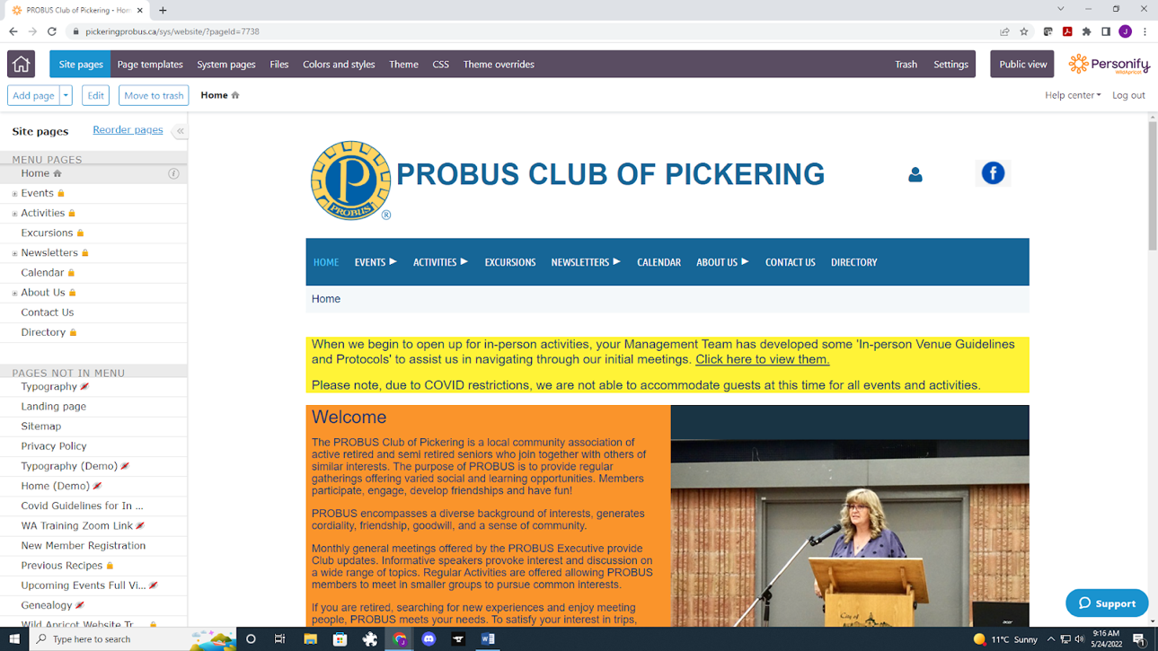
- Click on the little blue man icon (top right of your screen) to review your profile
- Click on My Event Registrations
- Click on the event that you want to cancel
- Click on already registered
- Select Cancel Registration

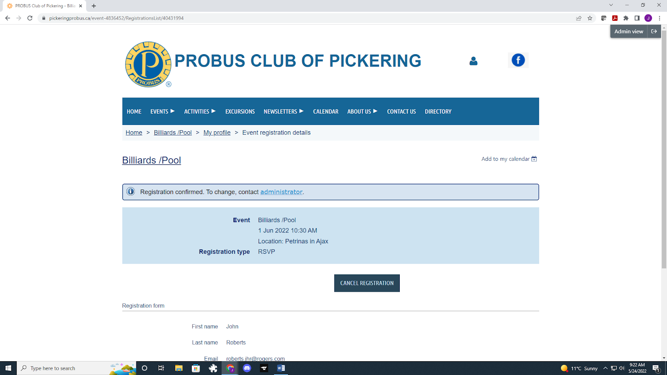

Another option to cancel your registration is directly through the Calendar view:
- Go to Calendar and select the event you want
- Click on the link ‘Already registered’
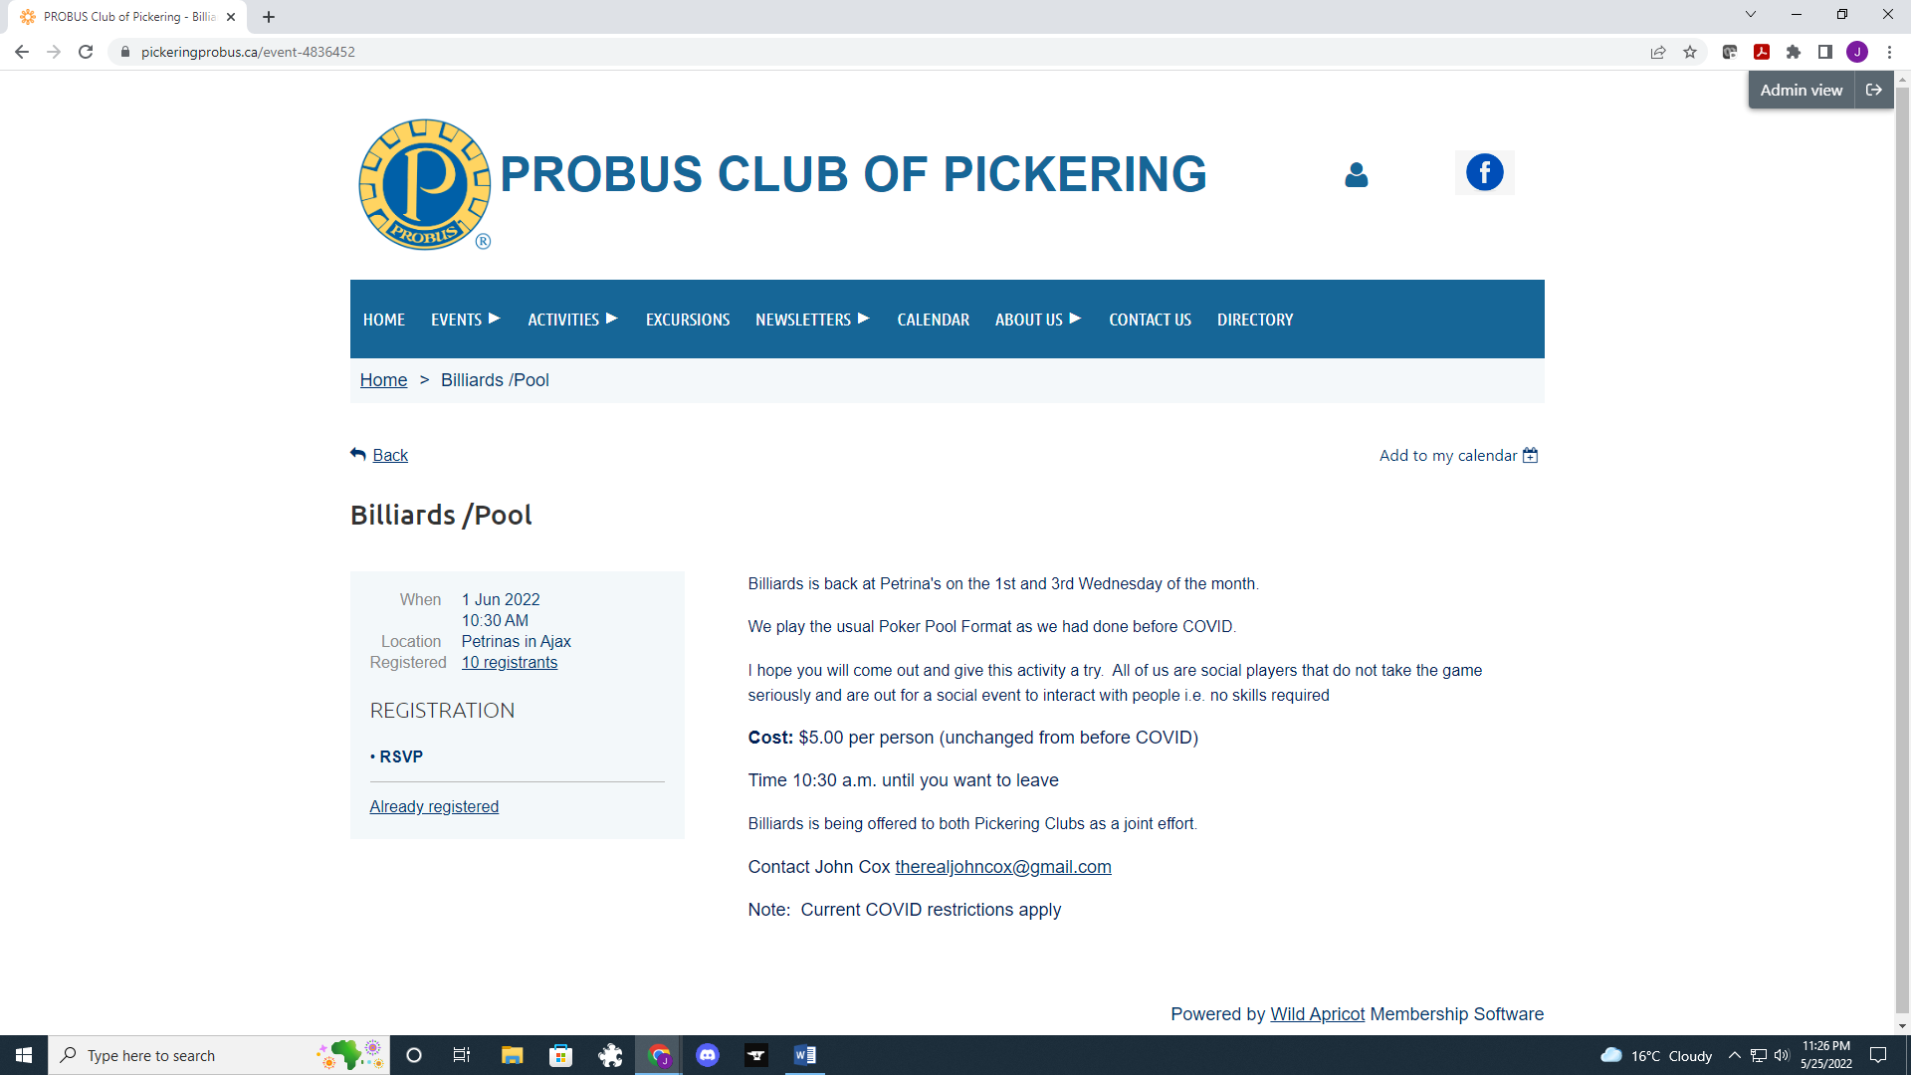
- Click on CANCEL REGISTRATION
NOTE:
The system will send you an email confirming your successful cancellation of the event.
If the system does not let you cancel please contact the event leader

